→ Here we will talk about **Model fitting, checkpoints, early stopping and callbacks using U-Net :**

**→ Let’s quickly revise our part 1 of U-Net :**

**(1) (1) Define width, height and channels of image :**

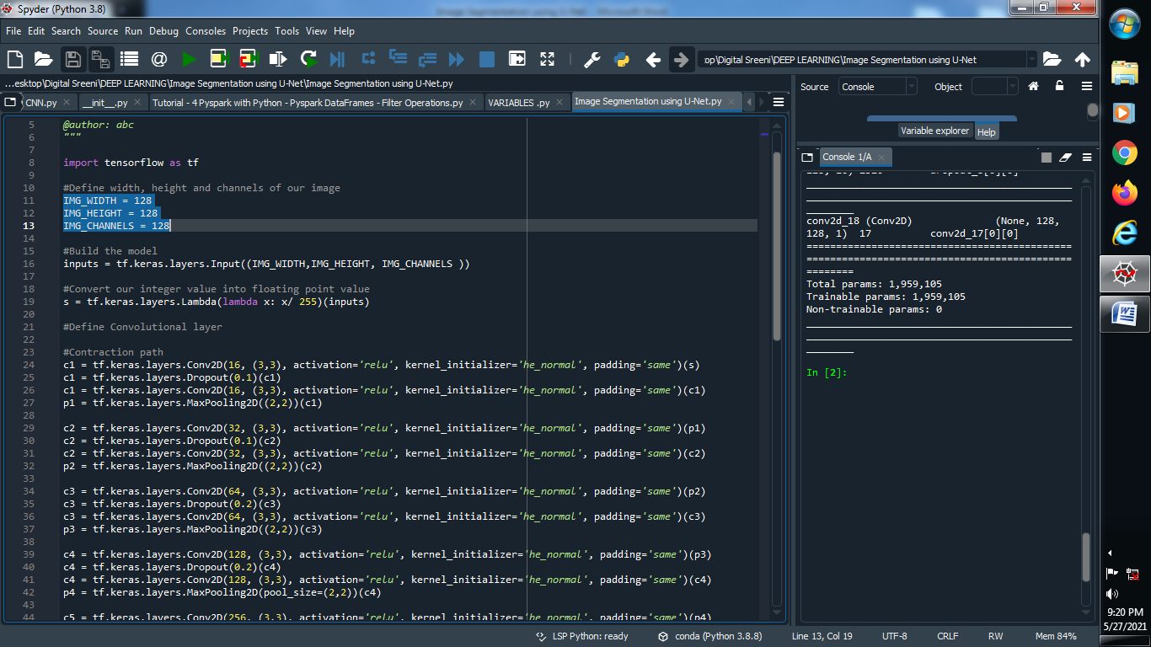

**(2) Build the model :**

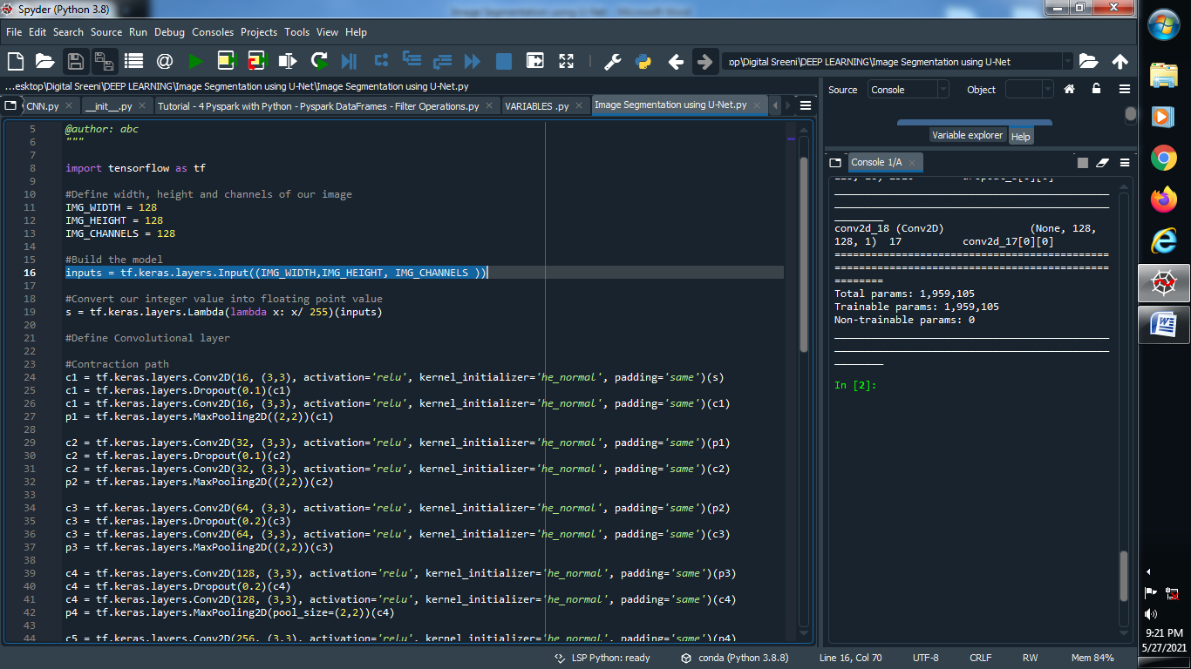

**(3) Convert integer value into floating point value :**

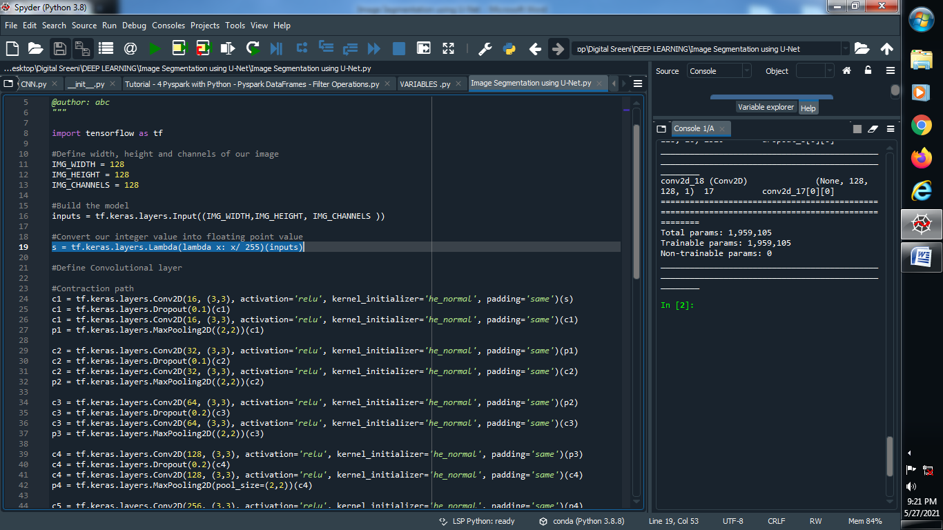

**(4) Define Convolutional layer :**

**→ Contraction path :**

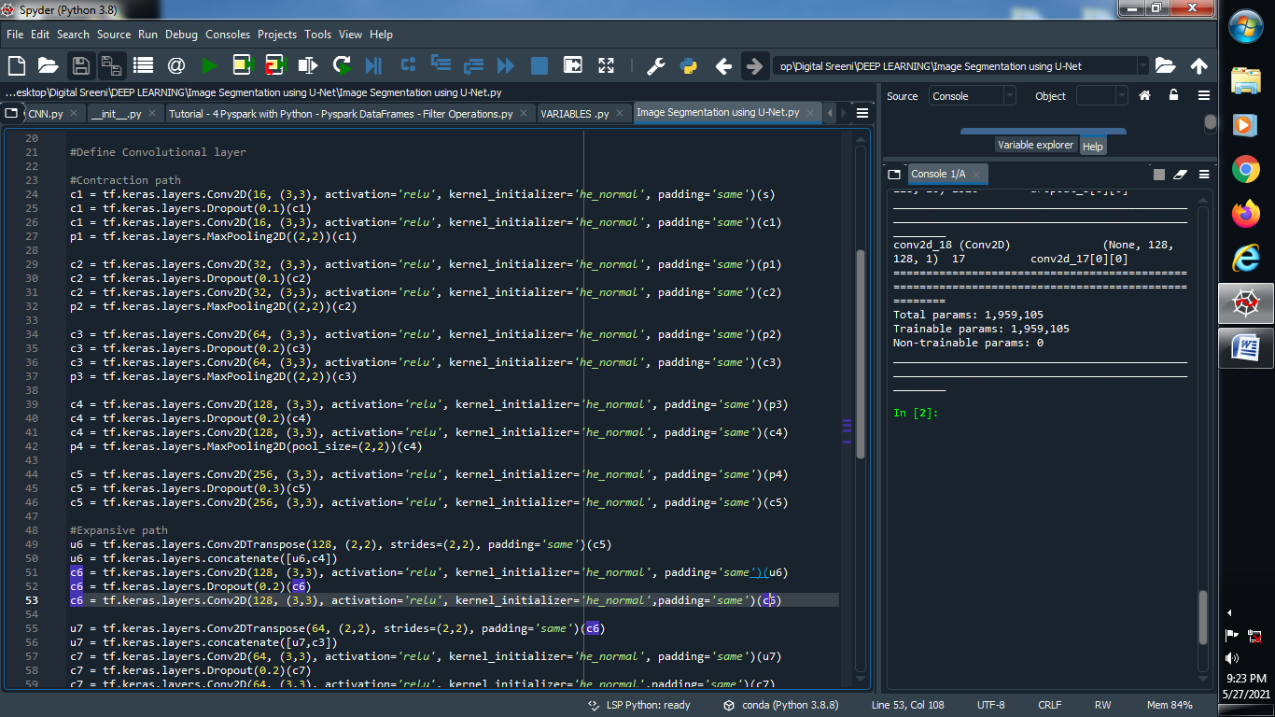

**→ Expansive path :**

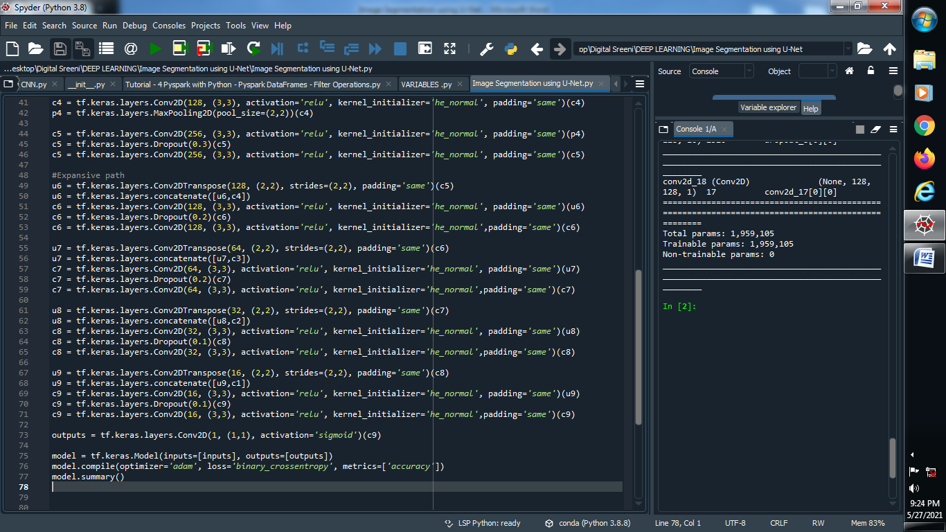

**(5) Define outputs :**

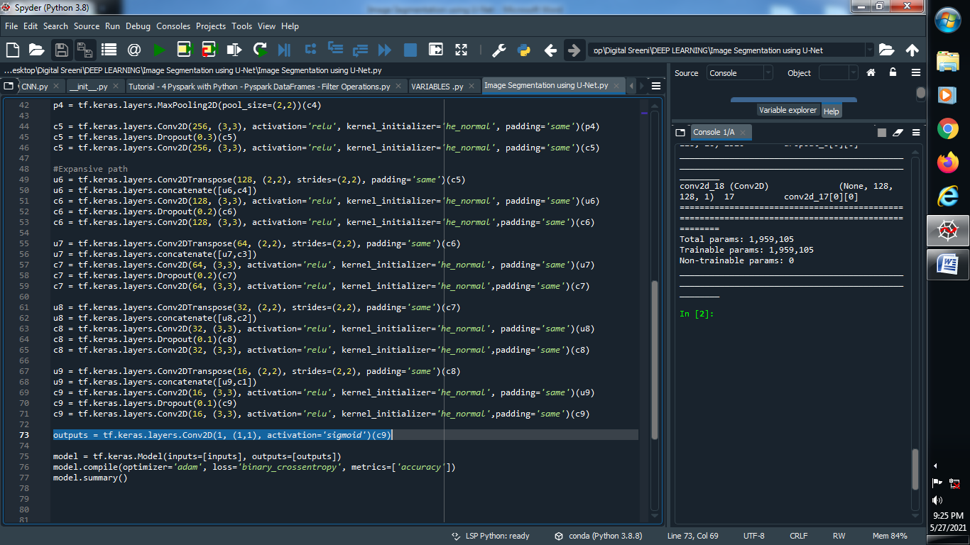

**(6) Compile the model and let’s see our output :**

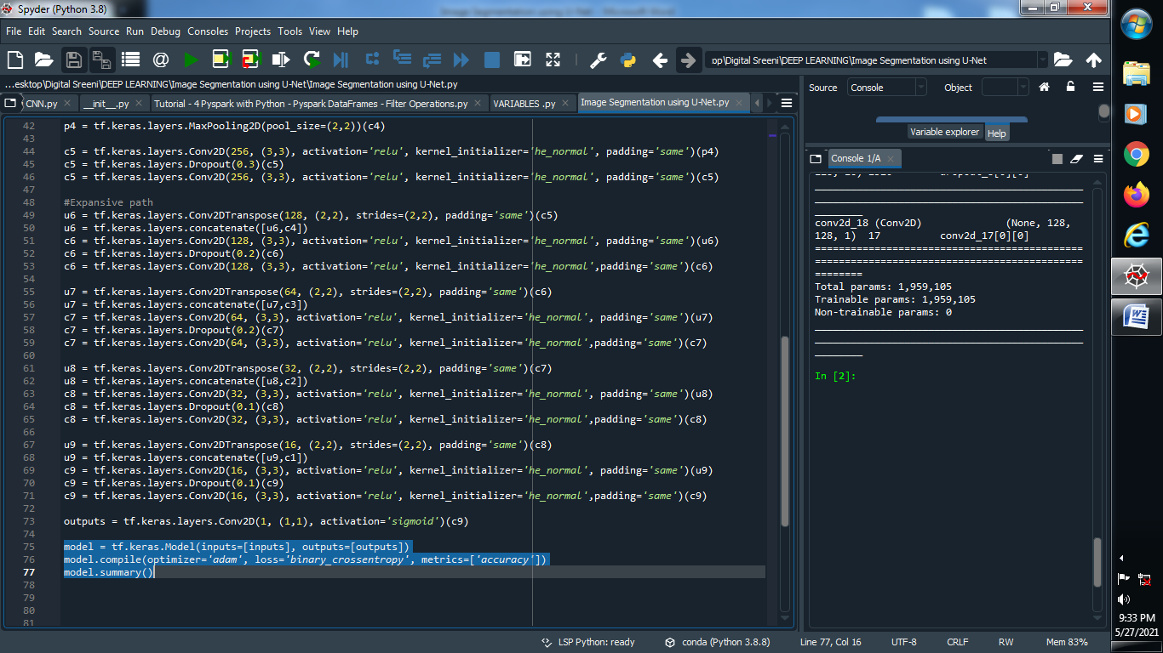

**Output :**

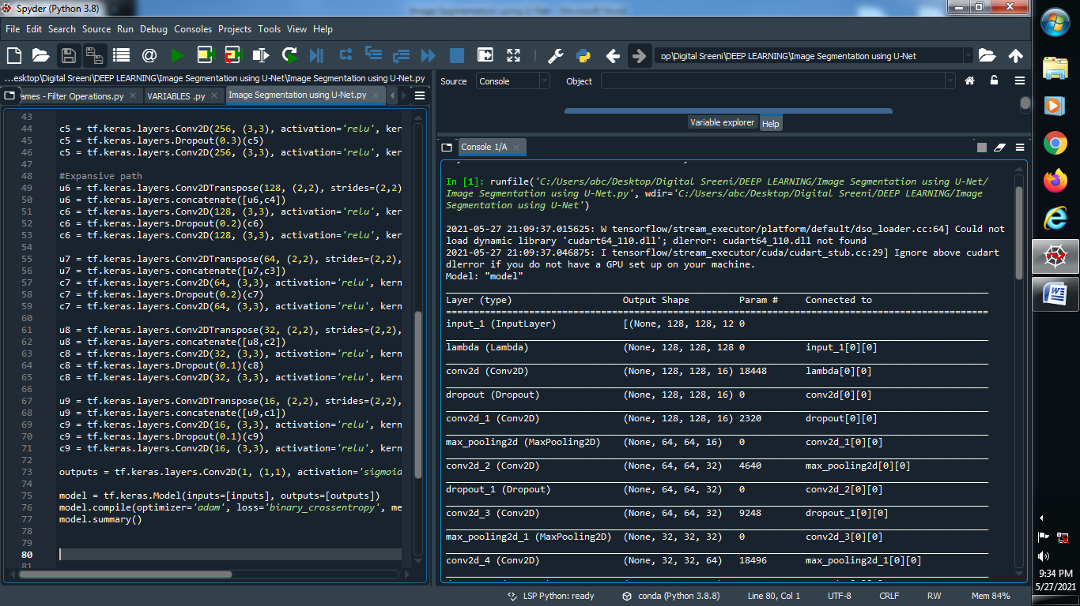

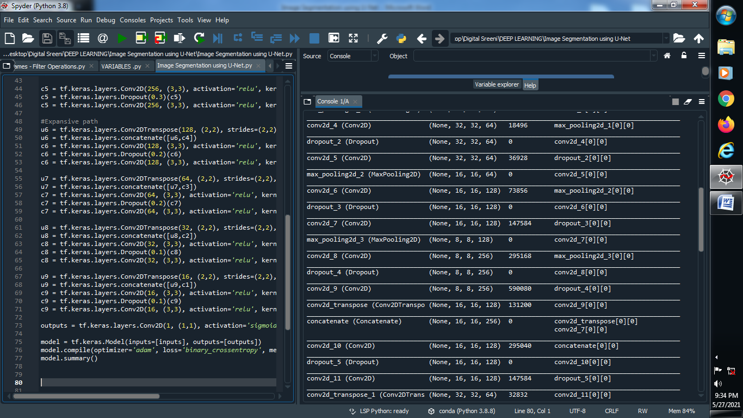

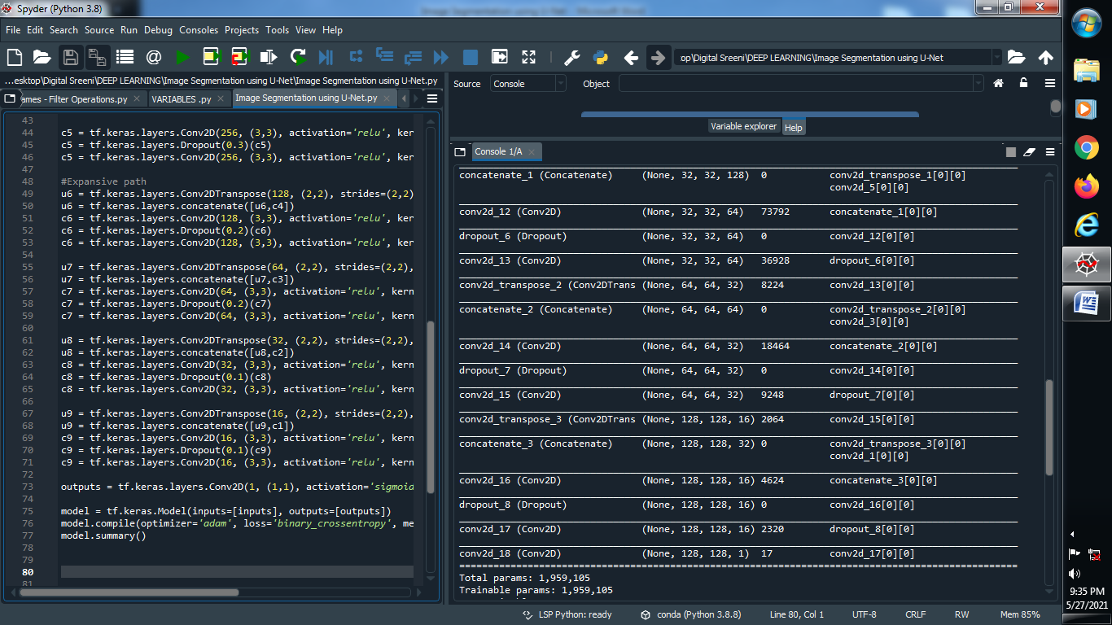

#####################################################################################

**→ Model fitting, checkpoints, early stopping and callbacks using U-Net :**

